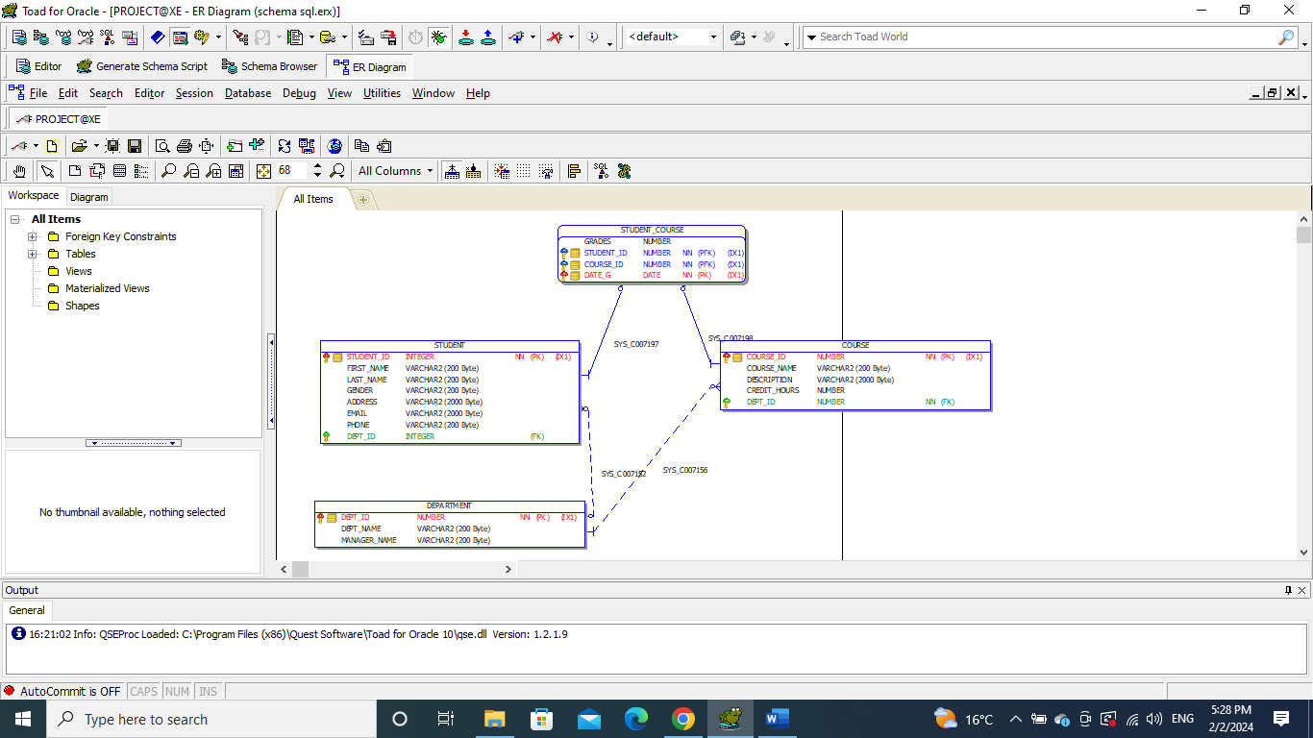

CREATE TABLE DEPARTMENT

(

DEPT_ID NUMBER NOT NULL,

DEPT_NAME VARCHAR2(200 BYTE),

MANAGER_NAME VARCHAR2(200 BYTE),

PRIMARY KEY (DEPT_ID)

);

CREATE TABLE COURSE

(

COURSE_ID NUMBER NOT NULL,

COURSE_NAME VARCHAR2(200 BYTE),

DESCRIPTION VARCHAR2(2000 BYTE),

CREDIT_HOURS NUMBER,

DEPT_ID NUMBER NOT NULL,

PRIMARY KEY (COURSE_ID),

FOREIGN KEY (DEPT_ID) REFERENCES DEPARTMENT (DEPT_ID)

);

CREATE TABLE STUDENT

(

STUDENT_ID INTEGER NOT NULL,

FIRST_NAME VARCHAR2(200 BYTE),

LAST_NAME VARCHAR2(200 BYTE),

GENDER VARCHAR2(200 BYTE),

ADDRESS VARCHAR2(2000 BYTE),

EMAIL VARCHAR2(2000 BYTE),

PHONE VARCHAR2(200 BYTE),

DEPT_ID INTEGER,

PRIMARY KEY (STUDENT_ID),

FOREIGN KEY (DEPT_ID) REFERENCES DEPARTMENT (DEPT_ID)

);

CREATE TABLE STUDENT_COURSE

(

GRADES NUMBER,

STUDENT_ID NUMBER NOT NULL,

COURSE_ID NUMBER NOT NULL,

DATE_G DATE,

PRIMARY KEY (STUDENT_ID, COURSE_ID, DATE_G),

FOREIGN KEY (STUDENT_ID) REFERENCES STUDENT (STUDENT_ID),

FOREIGN KEY (COURSE_ID) REFERENCES COURSE (COURSE_ID)

);